**Explain inheritance, Encapsulation, Abstraction, and Polymorphism in OOPS.**

**What is inheritance?**

Inheritance gives you to define a class that takes all the functionality from a parent class and allows you to add more.

**Why inheritance?**

1. Reusability of code
2. Saves time
3. Good structure of code

**What is Polymorphism?**

Polymorphism in JavaScript refers to the concept of reusing a single piece of code multiple times.

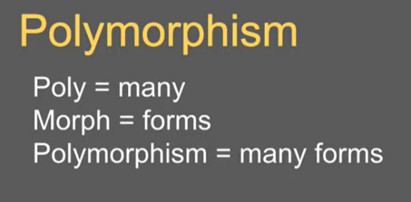

**What is Encapsulation?**

Rapping up data and methods under a single unit/class called encapsulation.

A mechanism of restricting direct access to some of the object’s components.

Method: getter and setter

**What is Abstraction?**

It’s a way of hiding the implementation details or irrelevant details, instead shows only the required one.

Example: Car process